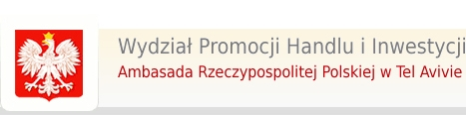 |      | 

REGISTRATION FORM
ECONOMIC MISSION

ISRAEL MIXiii BIOMED & HI-TECH 2014

19 – 22 of May 2014

Tel Aviv, Israel

_______________________ __________________________________
_________________________________________________________

Company information

Company name
Street
ZIP code
Town
Tax Identification Number
Telephone
Fax
E-mail
WWW
Participant name
Position
Email
telephone

Sectors of business activity, technology
Medical Devices  Pharmaceuticals  Laboratory diagnostic  Biomedicine | Nanomedicine  Bio-IT  IT/ICT  Nanobiotechnology  OTHER

Description of your company (activities, technology, products and services)

Cooperation types requested
Suppliers  Production capacity  Research & Development  Subcontracting agreement  Joint venture agreement | Investment objects  Technical cooperation  License agreement  Manufacturing agreement  Other

Description of requested type of cooperation

